DECEMBER 10, SECOND SUNDAY OF ADVENT YEAR B
PREPARE THE WAY OF THE LORD
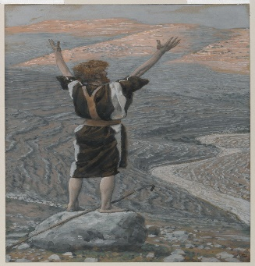

Isaiah 40:15.9-11, 2 Peter 3: 8-14, Mark 1:1-8; Maranatha! Come, Lord Jesus Come!
It is hard to fathom that we are already in the second week of Advent. As you all know the endless December tasks of: take part in this, do not forget to finish this assignment, do this, go there, and so on. Therefore, this liturgical season of advent requires a deliberate focus to slow down. In particular, the church is calling us to reflect on the good news that this Advent season brings.
The scripture readings of today, speak to the depth of our human need for God’s mercy. Isaiah’s prophesy of consoling, and comforting my people, is a great hope raiser that our God is coming with power.
Christ uses the metaphor of a shepherd feeding his flock, gathering lambs in his arms, holding them against his breast, and gently leading the young ones. Depicting a God who loves and cares, this second Sunday, we hear a voice that is heard in the desert full of consolation for God’s people, and calling us to conversion. John the Baptist wants those who have lost hope, the hungry children, those suffering from substance abuse, the homeless, those with terminal illnesses, those in war-torn countries, those in pain, the lonely, and many others to hear this message of hope and love of Emmanuel, God who is always with us brings.
For He who comes to rescue us forgives and renews our lives. Jesus is coming not just into our world but into our homes, communities, institutions, lives, and hearts. He is coming to gift us with His deep never-ending faith-fullness and companionship. May this gift come from deep within ourselves and blossom into other gifts of kindness, attentive listening, thoughtfulness, prayer, generosity, tolerance, compassion, caregiving, intentionally helpful deeds, and supportive comments that lead to growth. As the year 2023 comes to an end, despite our busy life with various activities, may we take this opportunity of advent to be still and hear the voice of John speaking to each one of us by name “Prepare away for the Lord, make straight His paths straight”. This is the time to say, God, we are sorry to forgive us for we have sinned.
God of hope opens up a pathway in our hearts and the world so that your Son can come to be born in us. Grant us the Grace of sincere repentance and conversion that we may worthily welcome Him in our midst. Humbly, we pray with the Psalmist of today, “Let us see, O Lord, your mercy and grant us your salvation”.
Betty Susan Nankya Nsanja Guadalupe

